CLP2 Series Installation Sheet
CLP2-25W-1X4
CLP2-25W-2X2
CLP2-50W-2X4

WARNING:
READ CAREFULLY BEFORE INSTALLING FIXTURE. RETAIN THESE INSTRUCTIONS FOR FUTURE REFERENCE.
Fixtures must be wired in accordance with the National Electrical Code and all applicable local codes.
Risk of fire or electric shock. Flat Panel installation requires knowledge of luminaires electrical systems. If not qualified,
do not attempt installation. Contact a qualified electrician. Be certain electrical power is OFF before and during installation and maintenance.
Flat Panel must be connected to a wiring system with an equipment – grounding conductor. Make sure the supply voltage is same as the rated luminaire voltage.
To prevent wiring damage or abrasion, do not expose wiring to edges of sheet metal or sharp objects.
No user serviceable parts inside of Flat Panel.
This product is indoor lamps, no waterproof function. Forbid using outdoor or moist places;
This product has dimming function, can be used with dimmer

Electrical Schematic
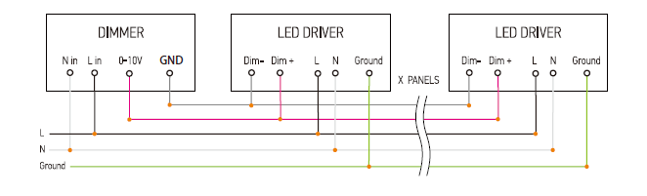

Recessed Installation
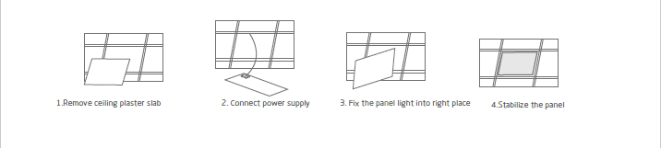
Suspension Installation
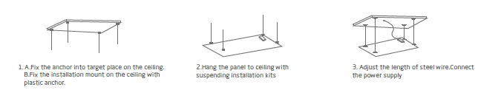
www.jdlighting.com
800.749.3920

4 6

